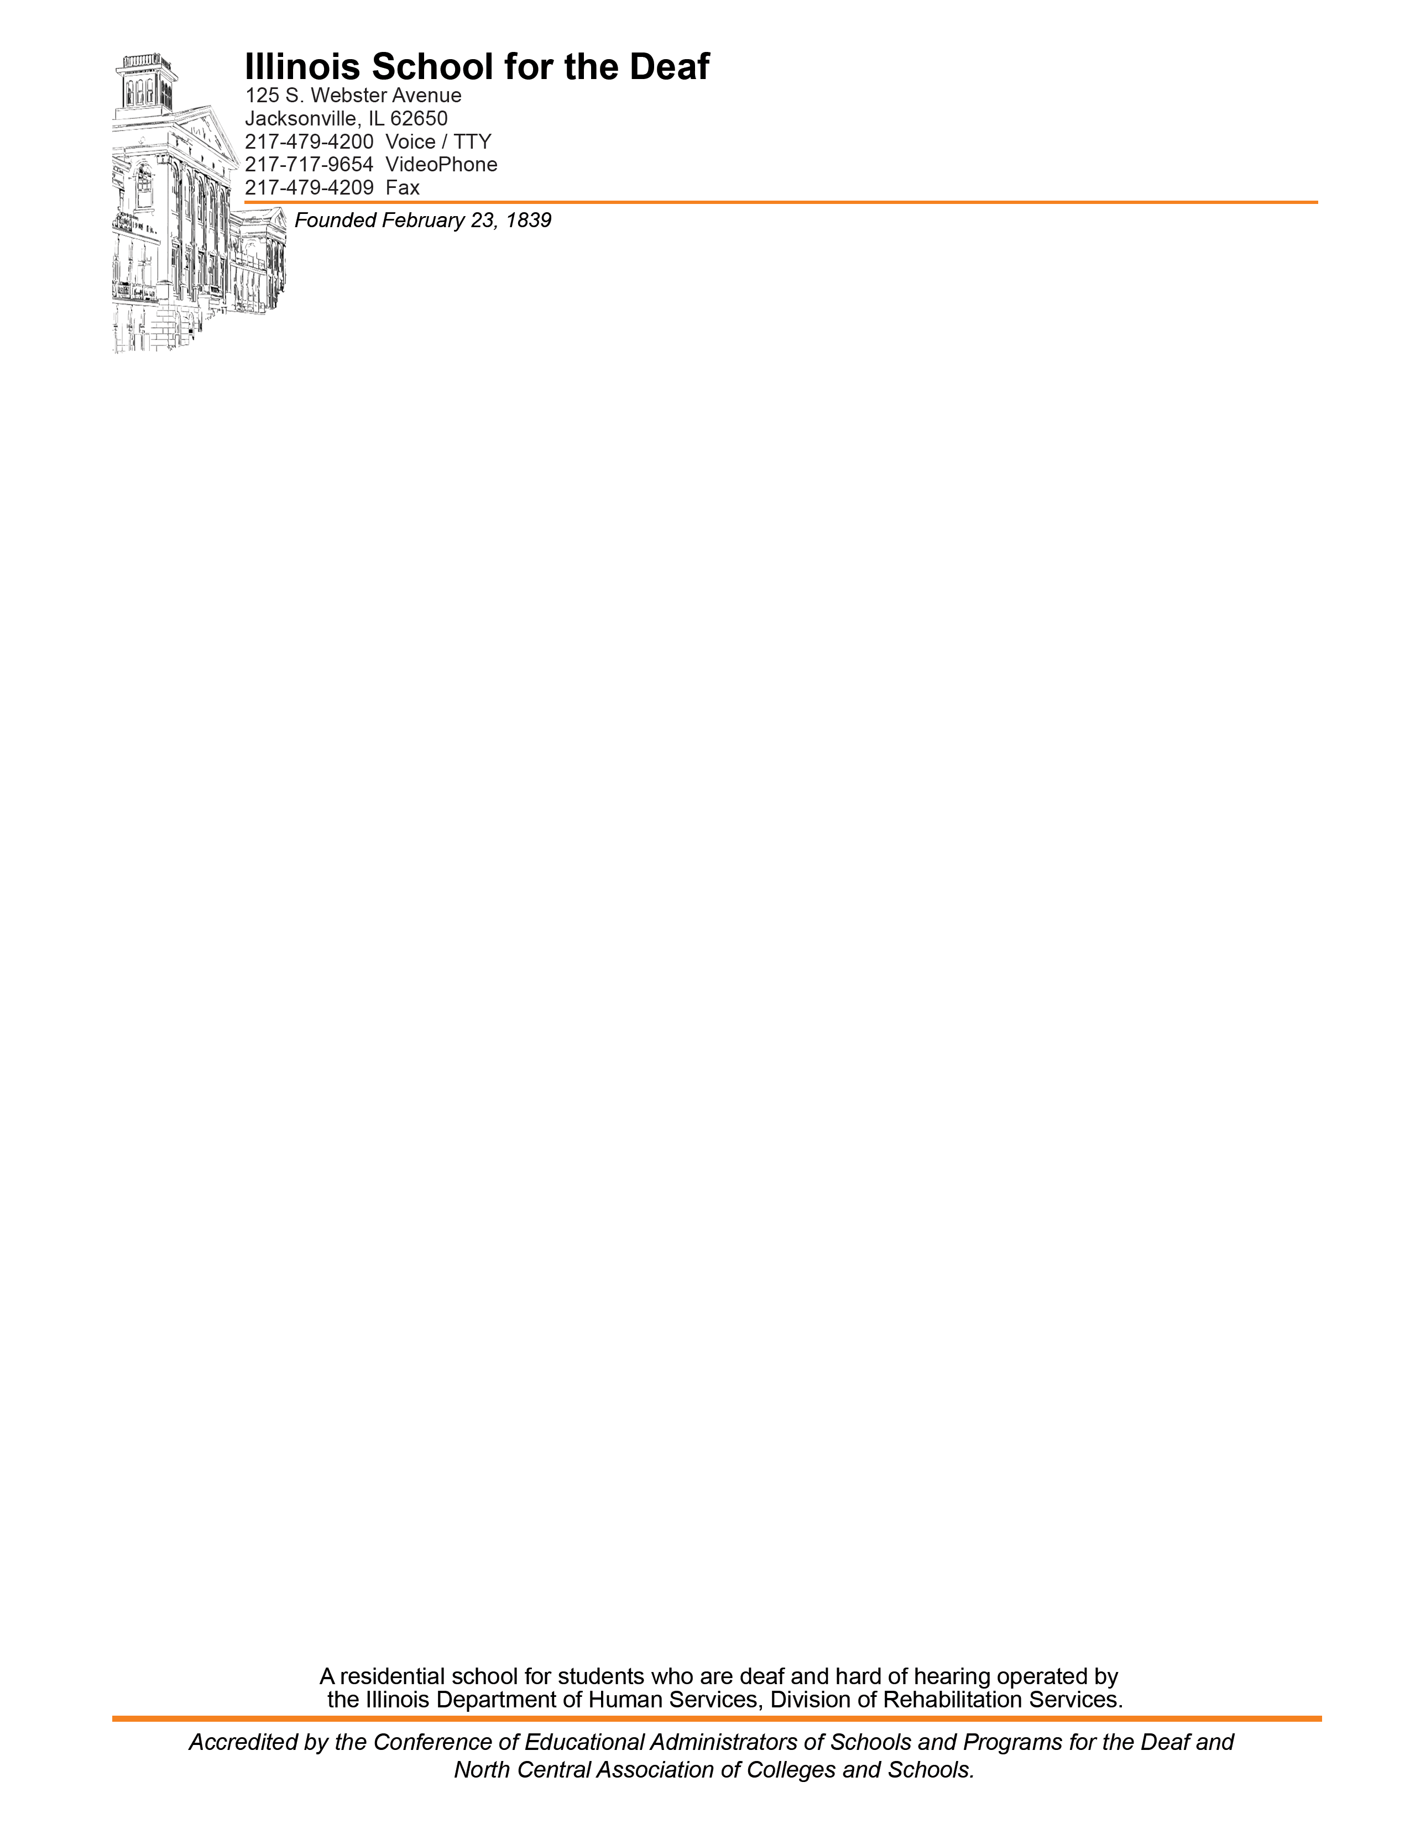

To: ISD Parents and Staff

From: Chris Fairfield, ISD Chief Engineer

Date: April 21, 2025

Re: Extermination schedule for 2025-2026

The following is a list of the dates American Pest Control will be on campus. On these dates American will spray pest control chemicals if required. ISD follows the latest Pest Control techniques. Chemicals are only used as part of our integrated pest management policy. The Illinois Department of Public Health outlines in detail the procedures we are to follow to prevent the use of chemicals in most situations.

We will follow the guide lines set in the Illinois Structural Pest Control Act (225 IL. 235/3.24).

Should applications of pest control chemicals be required between these dates, notice will be given to those parents and staff on our registry list prior to the application except in case of immediate health concern cases. If you would like to be included on our Pest Control Registry, please reply with your desire to be added to the notice registry to this e-mail.

American Pest Control will be on campus on the following dates:

July 11th and 25th, 2025

August 8th and 22nd, 2025

September 5th and 19th, 2025

October 3rd and 17th, 2025

November 7th and 21st, 2025

December 5th and 19th, 2025

January 9th and 23rd, 2026

February 6th and 20th, 2026

March 6th and 20th, 2026

April 3rd and 17th, 2026

May 1st and 15th., 2026

June 5th and 19th, 2026